

**Emmanuel Jojoe Ainoo**

**2019**

B.Sc. Computer Science

**APPLIED PROJECT**

**THE USE OF VOICE INTERFACE SYSTEMS TO AUGMENT SELLING AND BUYING ON UNIVERSITY CAMPUSES**

**ASHESI UNIVERSITY COLLEGE**

**DECLARATION**

I hereby declare that this applied project is the result of my own original work and that no part of it has been presented for another degree in this university or elsewhere.

Candidate’s Signature:

..............................................................................................................................................

Candidate’s Name:

..............................................................................................................................................

Date:

..............................................................................................................................................

I hereby declare that preparation and presentation of this applied project were supervised in accordance with the guidelines on supervision of applied project laid down by Ashesi University College.

Supervisor’s Signature:

..............................................................................................................................................

Supervisor’s Name:

..............................................................................................................................................

Date:

..............................................................................................................................................

**ACKNOWLEDGEMENT**

I would firstly like to honor God, my family, my supportive friends and lecturers who stood by me and assisted me in building this project and achieving my goals.

I would like to express my intense gratitude to my project supervisor Mr. Dennis Owusu, for his involvement in the project from the very start till the end, instrumental guidance, suggestions and criticisms through the successful completion of this project.

I also wish to thank my parents for their support in all areas. They provided resources especially with regards to payment of subscriptions for particular application programming interfaces (API’s) used in building the project.

Lastly, this project would not have been a success if the feedback from the various faculty during progress presentations were not present. The feedback guided me and drew insights so concerns I may never have thought of, and for that I thank them all.

**ABSTRACT**

Our everyday shopping lives have been significantly augmented by rapid advances in Commerce Technologies [1]. Buying and Selling of items as well as payments are currently mostly done online using advanced technologies, which have sped up shopping activities and made lives more comfortable for consumers.

In spite of the rise in e-commerce, e-business, internet communication, and payment systems, physical cash is still popularly used in buying and selling of items on the University Campus in Ghana [2]. There is no issue with that. However, a lot more problems surface when the seller has to give change to the buyer. The inconvenience of getting change for buyers especially when the change amount is quite small, such as GHC 20 pesewas is becoming menacing. This project thus seeks to reduce the inconveniency associated with change collection during buying and selling by allowing students and staff to accumulate their change amounts electronically through voice interface systems.

This paper presents a comprehensive implementation of the OkNsesa system which comprises of speaker recognition and speech recognition components to allow users update their electronic accounts using voice commands. The key advantage of using voice interfaces is the ability to automatically log users into the system by recognizing who the user is from his voice.

**TABLE OF CONTENTS**

DECLARATION……………………………………………………………………………1

ACKNOWLEDGEMENT…………………………………………………………………..2

ABSTRACT…………………………………………………………………………………3

Chapter 1: Introduction…………………………………………………………………….. 6

* 1. Aim………………………………………………………………………………6
  2. Background and Motivation……………………………………………………..6
  3. Problem Statement………………………………………………………………7
  4. Proposed Project…………………………………………………………………8
  5. Contributions…………………………………………………………………….9
  6. Related Work…………………………………………………………………….9

Chapter 2: Requirement Analysis………………………………………………………… 11

2.1 Requirements Gathering………………………………………………………..11

2.2 Functional Requirements……………………………………………………….11

2.3 Interface Requirements…………………………………………………………13

2.4 Non-Functional Requirements………………………………………………….14

Chapter 3: Architecture and Design………………………………………………………...15

3.1 Design and Analysis…………………………………………………………….15

3.2 System Modelling………………………………………………………………19

Chapter 4: Implementation………………………………………………………………….24

4.1 Implementation Components………………………………………………….. 24

4.2 Speaker Recognition……………………………………………………………24

4.3 Speech Recognition…………………………………………………………….26

4.4 Database………………………………………………………………………. 26

4.5 Interface………………………………………………………………………...27

4.6 Implementation Techniques……………………………………………………27

4.7 Implementation Issues………………………………………………………… 28

4.8 Evidence of Implementation……………………………………………………29

Chapter 5: Testing and Results

**LIST OF FIGURES**

**CHAPTER 1: INTRODUCTION**

This Chapter introduces background of the problem associated with change collection and the proposed solution to solving the problem.

1. AIM

The project seeks to explore the use of Voice User Interfaces (VUIs) to augment buying and selling in Ashesi University. The aim of the project is to build a Natural Language Processing System that uses voice features and commands to allow users accumulate change amount electronically. Users are automatically recognized and verified to access their account based on their voice features. Users from there can now use voice commands such as “Update my account with GHC 2”, to actually update their specific change accounts and use the cash accumulated for other purchases.

1. BACKGROUND AND MOTIVATION

The Ashesi University Population continues to increase every year [9]. Thus, buying and selling on campus increases consequently. Out of 30 students who use cash in purchasing items, 30 of them can recall an instance where they left some amount of change with the seller. As time moves on, and a lot more enter the university, the issue continues to aggravate. A lot more people complain about the issue, but it never gets addressed. It has swollen to an extent where people have accepted the problem and live with its consequences.

An approach to solve this problem, proposed by the shop owners themselves, is a paper-receipt containing the change amount and date of purchase to buyers, with the idea that buyers can use the chit later for another purchase or to directly receive the cash equivalent. However most of the time, these papers get destroyed or lost.

Certain times, sellers either keep the change or merely tell buyers to come for their change later. Both buyers and sellers forget this day ever been mentioned or the exact amount. In more frustrating situations, sellers do not collect the full amount needed to buy a product to avoid needing to get change. For instance, a seller may collect GHC 2.00 for an item that costs GHC 2.40. Other occasions, buyers are forced to purchase extra items or purchase items in a manner, such that change collection, is avoided. The current approaches to handling these problems are not satisfactory and tend to create auxiliary issues.

Buyers complain of losing change as well as sellers. It negatively impacts customer experience, and in effect, cripple the business. Also, there is a considerable sum of money lost in the system, primarily when the lost receipts are not accounted for.

Another redundant way in which shops try to tackle the problem is by keeping a record of change to give to buyers using a book. A lot more drawbacks with this approach stem from the issues with the traditional File Approach of record keeping such as the inefficiency involved in searching for a particular record [10].

A few shops make use of Graphical User Interfaces (GUI’s), which speed up processes using intuitive controls [4]. The drawback of these systems is that they do not directly account for providing change buyers and in situations tend to slow transaction processes [5].

1. PROBLEM STATEMENT

Though there may be no issues with regards to purchasing with physical cash, a lot more problems surface when the seller has to give change to the buyer.

The frustration involved in giving out change in Ghana has long existed though has been tried to be reduced minimally by a change in currency to the Ghanaian Cedis [3].

The inconvenience of getting change for buyers especially when the change amount is quite small, such as GHC 1.50 pesewas, 20 pesewas, etc. is nerve-wracking.

1. PROPOSED PROJECT

The project seeks to build a system that will allow sellers to give buyers electronic change through a voice interface and thus enhance the buying and selling of items on the Ashesi campus.

A voice interface may be a quick and efficient way for sellers to provide change [6]. The basic idea is for buyers' change to be converted to electronic currency which can be used for other purchases. This process of converting change to electronic money during a purchase must be fast enough to be worth it. Sellers and buyers alike may be reluctant to waste precious time on 20 or 50 pesewas change.

In the situation where the seller may not have the exact change to give to the buyer, the buyer could say, for instance, "ok Nsesa, 50 pesewas change" and their electronic account gets credited. All the seller has to do is confirm the transaction of the change, at the particular instance, to approve the crediting. I assume it will be faster and more convenient than having to navigate a graphical user interface to perform the same task [8]. Part of the speed and convenience of voice interfaces lies in the fact that voice instructions can simultaneously be used for identity determination and authorization and thus skipping the process of logging in with a GUI [7].

1. CONTRIBUTIONS

The contributions of this project would be as follows:

1. A voice interface system for buying and selling food on the Ashesi Campus
2. Electronic change that can be integrated with other electronic currencies
3. An interactive voice system to allow buyers query transaction details
4. An electronic piggy bank for change
5. Presenting research on the problem of getting change
6. RELATED WORK

General research and reporting on the issue of difficulty in getting change for buyers have not been formally and adequately contributed to academic knowledge. Thus, a good number of systems have not been developed as an approach to handling the issue.

However, concerning the various technologies, i.e., Spoken Language Understanding (SLU), Speaker Identification and Verification, Speech Recognition, etc. involved in developing a such a system, there has been a great deal works contributed.

**1.6.1 Improved VUI system based on maintenance device.**

This paper proposes a design of an improved VUI system based on maintenance device which comprises a speech recognition system, a menu system, and a module update system. The authors model a design a framework of a Voice User Interface (VUI) that consists of Voice Interface of Mental Models which is deals with transmission of messages and a Voice Interaction Model which allows the exchange of information through speech [11]. The Speech Recognition aspect of designed by the authors of which relates directly relates to the project being built was implemented as the first unit of the entire system. The speech recognition system takes input from the user as voice, then it is appropriately analyzed and recognized using recognition algorithms, and then the resulting data is what the menu system uses to make a choice [11].

**1.6.2 u**

The paper above presented by professors of the College of Science and Technology, Nigeria, seeks to introduce a speech-based e-learning system, especially in an attempt to address the issue e-learning platforms have with regards to usage by visually impaired learners and dyslexia.

The VUI design the authors propose allows for voice authentication as well. In this part of the system, the user interacts with the system using voice responses to access e-learning sources. It uses stemming algorithms for comparison of keywords and user’s voice responses to find accurate matches [12]

**1.6.3 Emotional speaker recognition based on i-vector through Atom Aligned Sparse Representation**

This paper speaks to improve the intelligence of speech recognition by taking into the analysis, emotional variability using i-vector with the Atom Aligned Sparse Representation (AASR) emotion synthesis algorithm.

**CHAPTER 2: REQUIREMENT ANALYSIS**

This Chapter discusses the requirement specifications of building the system and how these requirements were gathered and analyzed to specify how the system should be built.

2.1 REQUIREMENTS GATHERING

OkNsesa is Voice Interface System that augments buying and selling by providing an avenue to handle difficulty in change collection. The idea is that the system would allow buyers to update an electronic account with the change amount given that the seller confirms the transaction.

The process involves buyers automatically logging onto the system when they decide to update an electronic account based on features derived from their voice. The buyer says for instance “ok Nsesa: update my account with 20pesewas”. A confirmation message is immediately sent to the seller, to confirm the crediting. The seller confirms, and the buyer’s account gets credited. The buyer can then use the credited amount for other purchases.

The stage of specifying requirements involved interactions with students, staff, and faculty as well as workers of Cafeterias and Shops both on and off campus, as they all form part of the user base. In determining the needs and requirements of the system, informal interviews with the potential users of the system.

These requirements underline the functionalities of the system that is required to solve the problem discussed above.

2.2 FUNCTIONAL REQUIREMENTS

This section explores the fundamental functions of the okNsesa system. It is divided into two:

1. User Requirements

2. System Requirements

**2.2.1 User Requirements**

This section summarizes the high-level needs of the user that have been transformed into achievable requirements based on direct interactions with the users of the system. These requirements are:

1. A buyer should be able to log in onto the system with his/her voice
2. A buyer should be able to update his electronic change account with a particular speech
3. A buyer should be able to check his/her past transactions using voice
4. A buyer should be able to update or make changes to his account
5. A buyer should be able to log out from the system
6. A buyer should be able to undo a transaction
7. A seller should be able to confirm a buyer’s change transaction
8. A seller should be able to request past transactions and records

**2.2.2 System Requirements**

This section outlines the specifications of the system, including what it should do and what it should not. These requirements are:

1. The system should have a voice interface that allows buyers to interact with the system
2. The system should have a speaker recognition system that automatically logs buyers into the system
3. The system should have an electronic change account for each buyer
4. The system shall update an electronic change account based on a change amount figure given in a speech by a buyer
5. The system should be able to recognize speech from the buyer to update
6. The system would not update an account until the seller has confirmed the update
7. The system would not allow a transaction to be undone if not approved by seller
8. The system shall perform rigorous security checks before allowing updates
9. The system should allow buyers to confirm their logging in
10. The system should reject any logging in based on a voice that it is not sure of and allow buyers to try again

2.3 INTERFACE REQUIREMENTS

This section outlines the specifications of the system’s interface of which the user interacts with.

1. The system shall provide a user-friendly interface that allows both buyers and sellers to interact and achieve their needs.
2. The system shall provide an interface for buyers to credit their account with change
3. The system shall provide an interface for sellers to confirm the buyer's crediting of the account
4. The system shall provide an interface for buyers to check past transactions
5. The system shall provide an interface for sellers to review recent transactions.
6. The system shall provide an interface for buyers to reuse credited account for other purchases
7. The system shall provide an interface to confirm users' login process when there are mismatches.

2.4 NON-FUNCTIONAL REQUIREMENTS

These requirements emphasize the quality attributes of the system to make the system usable. These requirements include:

1. Security: The system would employ features to ensure that the information that is stored in the system is safeguarded from both internal and external attacks.
2. Available: The system would be available to use 24 hours a day, seven days a week.
3. Confidentiality: All user information shall only be accessed by authorized personnel.
4. Usability: System shall be easy to use, and consistency with regards to user actions would be enforced.
5. Reliability: System shall consistently perform specified functions without failure.
6. Safety: System shall bring no harm to users.
7. Integrity: System shall ensure that user data is maintained without any corruption.
8. Maintainability: Problems with the system shall easily be fixed.
9. Portability: The system shall deploy on both desktop and mobile platforms.

**CHAPTER 3: ARCHITECTURE & DESIGN**

3.1 DESIGN AND ANALYSIS

The OkNsesa System is an application that allows buyers to store change amounts and reuse for later purchases performs a number of processes to allow this functionality. The system is designed to provide a platform where buyers can speak to the system and sellers can confirm a transaction.

**3.1.1 System Overview**

The application would allow buyers to login automatically when they speak, through a number of voice features. However, an alternative login would be available when there are issues with recognizing a user’s voice or the system rejects access due to incorrect voice matching, for security reasons. We do not want a buyer logging in to another buyer’s account because confused voice feature recognition or accents, as such the traditional login with a secured password would be popped-up. Similarly, buyers can logout with a voice command. The application would allow users to update their electronic accounts with the change amounts given that they have successfully logged-in.

Buyers say a specific voice command “Update my Account with change amount (say 20 pesewas or 50 pesewas)”. They can then later check how much they have in their account by saying a specific command “How much do I have in my account?”. Assuming the buyer has accumulated change enough to make expensive purchases, he/she can then use the money on the account in any of the shops on campus.

Though the voice commands passed to the system may be syntax or structure-specific, the system would be flexible enough to allow certain variations to the commands, for example “Add 20 pesewas to my account” instead of “Update my Account with 20 pesewas” due to the machine learning algorithms incorporated.

Sellers receive a confirmation popup, to confirm whether, the buyer’s request to update his/her change account with a particular amount is accurate. Thus, the updating process must be done in the presence of both buyers and sellers, in order to solve issues of over or under-estimate of change amounts.

**3.1.2 High-level Architecture of System**

The system is organized into four main components: Speaker Recognition System, Speech Recognition System, Change Account System and an Interactive Interface. These four components constitute the process of a buyer, updating his electronic account with a said change amount, after confirmation from the seller as described above. The components work as a single unit in rendering this functionality to the buyers and sellers

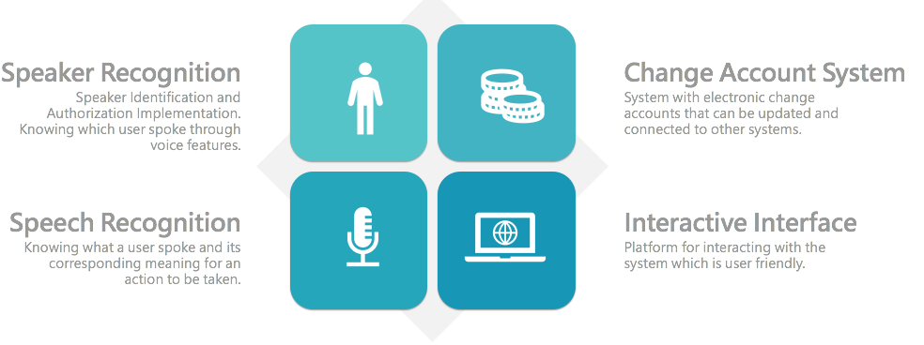

Figure 3.1 System Design

*Speaker Recognition*

The Speaker Recognition component of the system is responsible identifying which buyer spoke, so as to map on to the right buyer account. Simultaneously, from the buyer’s speech, he/she would be logged into the system automatically, after identifying and verifying it is the right mapping on to a buyer.

*Speech Recognition*

The Speech Recognition component of the system is responsible for understanding a what exactly a buyer said, to trigger an action, for instance update account or display transactions. The component, using appropriate optimization algorithms, would process buyers’ speech input such that spelling correction and wrong input would be handled to avoid the buyer from repeating speech multiple times.

*Change Account System*

This component is responsible for the managing of buyers’ change account with regards to creating, updating and deleting accounts. Buyers can accumulate change amounts and use for later purposes, thus they need to be able to constantly check how much accumulated change they have so far, to know their purchasing power.

*Interactive Interface*

The user needs to communicate with a user-friendly interface that allows him/her to record speech and manage account. The interface would be partly Graphical and partly Voice, however, all interactions with the system would be via speech, based on the assumption that it is much faster than the traditional graphical interaction.

A screenshot of a cell phone


Figure 3.2 System Architecture

**3.1.2 The Actors of the System**

1. S

**3.1.3 Scenarios**

The following represents varying scenarios in using the on-campus room allocation system:

1. Scenario 1 – Scenario of Buyer when seller has no change
2. Scenario 2 – Scenario of Buyer when repurchasing
3. Scenario 3 – Scenario of Buyer automatic log in and not wasting time has a class
4. Scenario 4 – Seller struggling to get change, buyer brings idea of OkNsesa

3.2 SYSTEM MODELLING

**3.2.1 Use Case Diagram**

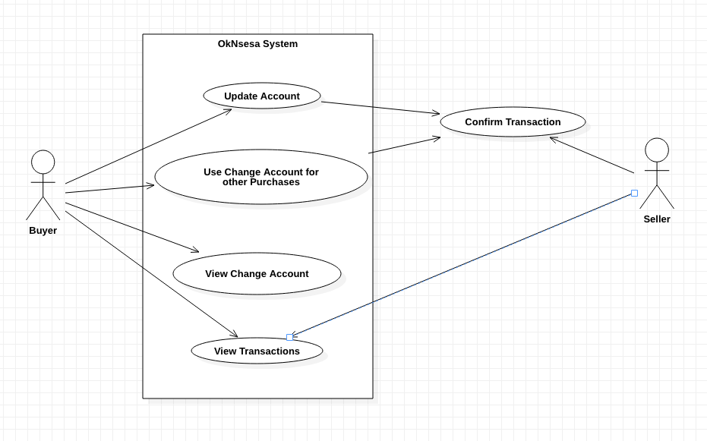

Figure 3.3 Use Case Diagram

**3.2.5 Activity Diagram**

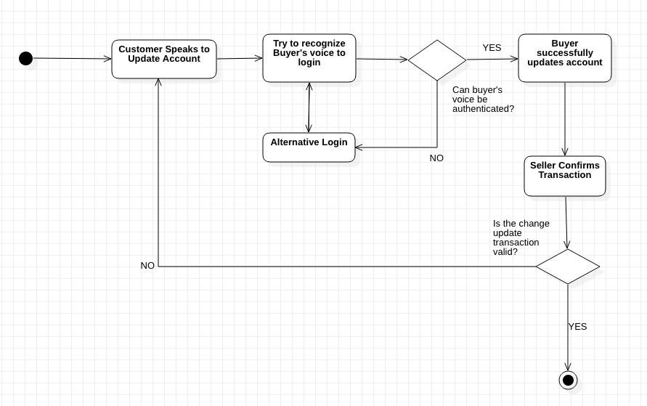

Figure 3.4 Activity Diagram for Buyers

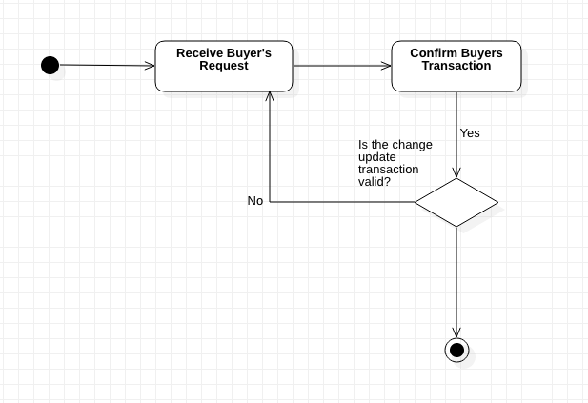

Figure 3.5 Activity Diagram for Sellers

**3.2.6 Sequence Diagram**

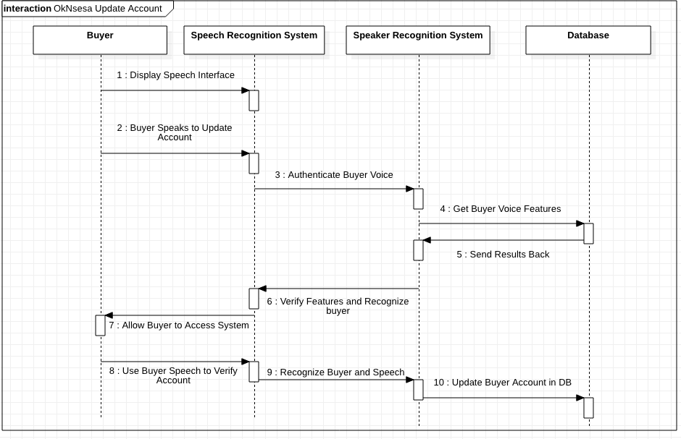

Figure 3.6 Sequence Diagram for Updating Buyers Change Account

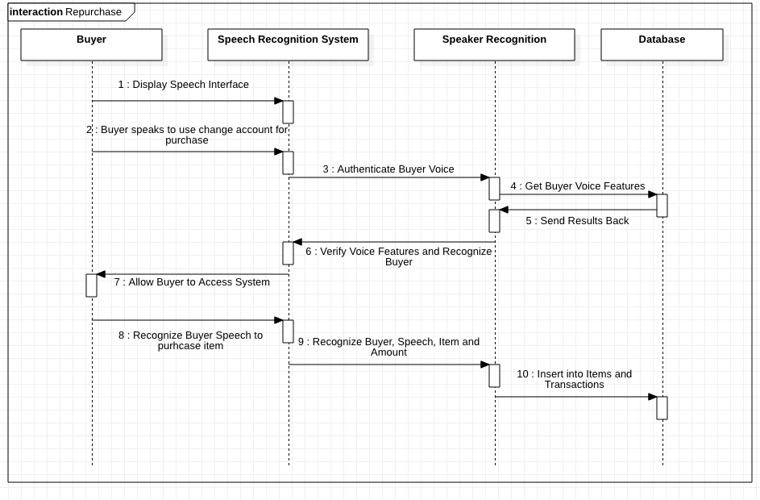

Figure 3.7 Sequence Diagram for using Change Amount for Repurchases

**3.2.7 Database Architecture**

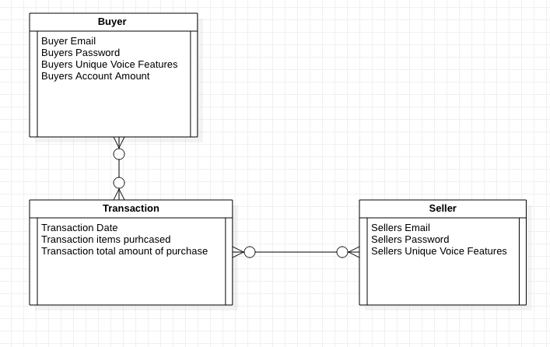

Figure 3.8 Entity Relationship Diagram

**CHAPTER 4: IMPLEMENTATION**

This chapter discusses the details of the implementation of the OkNsesa system and how different components used to build the system interact. The chapter is divided into sections discussing the four major components of the system and the technologies implemented to allow these components function.

4.1 IMPLEMENTATION COMPONENTS

Since the project is heavily designed with machine cognitive concepts i.e. Speaker Identification, Speaker Verification, Speech Recognition, machine learning libraries prebuilt were used to perform these individual complex tasks were used. The system as explained in the beginning chapter is a platform to allow users to easily accumulate change amount that could have been lost. The core of the system is organized as a process of Speaker Identification, Speaker Verification, Speech Recognition then Account Update.

4.2 SPEAKER RECOGNITION

Speaker Recognition involves two major tasks Speaker Identification which seeks to find a match of a voice pattern among a set of voice patterns and Speaker verification which seeks to confirm a voice pattern matches a predefined voice pattern. Both Speaker recognition and Identification tasks were completed using Microsoft’s Cognitive Services API for speaker recognition. These two separate tasks are executed sequentially, however communicate in a seamless means which would be explained below.

**4.2.1 Identification**

Speaker Identification APIs can automatically identify the person speaking in an audio file, given a group of prospective speakers. The input audio is paired against the provided group of speakers, and in the case that there is a match found, the speaker’s identity is returned.

All speakers should go through an enrollment process first to get their voice registered to the system and have a voice print created.

*Enrollment*

Enrollment for speaker identification is text-independent, which means that there are no restrictions on what the speaker says in the audio. The speaker's voice is recorded, and a number of features are extracted to form a unique voice signature.

*Identification*

The audio of the unknown speaker, together with the prospective group of speakers, is provided during recognition. The input voice is compared against all speakers in order to determine whose voice it is, and if there is a match found, the identity of the speaker is returned.

**4.2.2 Verification**

Voice has unique characteristics that can be used to identify a person, just like a fingerprint. Using voice as a signal for access control and authentication scenarios has emerged as a new innovative tool –essentially offering a level up in security that simplifies the authentication experience for customers.

Speaker Verification APIs can automatically verify and authenticate users using their voice or speech.

*Enrollment*

Enrollment for speaker verification is text-dependent, which means speakers need to choose a specific pass phrase to use during both enrollment and verification phases. In enrollment, the speaker's voice is recorded saying a specific phrase, then a number of features are extracted, and the chosen phrase is recognized. Together, both extracted features and the chosen phrase form a unique voice signature.

*Verification*

In verification, an input voice and phrase are compared against the enrollment's voice signature and phrase –in order to verify whether or not they are from the same person, and if they are saying the correct phrase

4.3 SPEECH RECOGNITION

Speech Recognition is the task recognizing what a speaker said in the form of text (source). The core of OkNsesa has to do with voice commands in allowing students/staff to add change amounts to their respective accounts, thus being able to extract what they say from a microphone is key. The Google Speech Recognition API embedded in python’s Speech Recognition library was used for the task in this project. (add more about how individual components were used)

4.4 DATABASE

The training audio data together with user profiles for Speaker recognition are stored in the Microsoft Cognitive Services API online and could be managed easily. Python’s SQLite was used to manage user’s account and balance updates. (add more about how individual components were used)

4.5 INTERFACE

F

4.6 IMPLEMENTATION TECHNIQUES

**4.6.1 Python**

In this project, Python is used significantly to code most of the system’s

functions. The choice for Python lies in its simplicity in allowing for easy readability and the execution of concepts and functions without the need for typing a lot of code.

**4.6.2 PyAudio**

**4.6.3 Flask**

**4.2.4 SQLite**

**4.2.4 Google Speech to text**

**4..2.6 Microsofot speaker recognition**

4.7 IMPLEMENTATION ISSUES

**4.7.1 Reuse**

In building the OkNsesa project, failing to admit the system was constructed by reusing existing components would be thievery. Existing components at different levels as mentioned above were used. Googles Speech Recognition and Microsoft’s Speaker recognition were integrated to build the system. The web interface was also implemented by reusing Flask design components with an SQLite backend. The display page was implemented as the basic design for displaying the transactions occurring at the because it has a simple and intuitive appearance that users easily understand where changes in values can be maximized for clearer visibility.

**4.7.2 Configuration Management**

The work was broken down into various sections of development and as such the changes needed to be managed. Thus, version management specifically git, was used to track changes with individual systems on a master repository and later all the various branches were merged and integrated to get the complete OkNsesa system.

**4.7.3 Host-Target Development**

Deployment falls within the range of future works for various reasons explained in the last chapter. The project was however developed on a local machine (the host) with a couple of software development platforms such as Atom, Sublime Text Editors, and other calls to API’s online. The project is to be deployed on the Ashesi Cafeterias coupled with a microphone. It would still make the API calls to the various Natural Language Processing (NLP) systems involved.

4.8 EVIDENCE OF IMPLEMENTATION

**CHAPTER 5: TESTING AND RESULTS**

**CHAPTER 6: CONCLUSIONS AND RECOMMENDATIONS**

**APPENDICES**

REFERENCES

[1] A. A. Azeta, C. K. Ayo, A. A. Atayero, and N. A. Ikhu-Omoregbe. 2009. A Case-Based Reasoning approach for speech-enabled e-Learning system. In 2009 2nd International Conference on Adaptive Science Technology (ICAST), 211–217. DOI:https://doi.org/10.1109/ICASTECH.2009.5409721

[2] A. Bassi. 1999. An associative semantic model for text processing. In 6th International Symposium on String Processing and Information Retrieval. 5th International Workshop on Groupware (Cat. No.PR00268), 31–37. DOI:https://doi.org/10.1109/SPIRE.1999.796575

[3] Denise Dahlhoff. Shopping by Voice a Hard Sell for Consumers. strategy+business. Retrieved October 3, 2018 from https://www.strategy-business.com/blog/Shopping-by-Voice-a-Hard-Sell-for-Consumers?gko=6b331

[4] G. Di, Y. Liu, L. Han, and J. Wu. 2008. Design and Implementation of Voice Web Pages for Online Shopping Based on .NET and Streaming Media. In 2008 International Conference on Management of e-Commerce and e-Government, 226–229. DOI:https://doi.org/10.1109/ICMECG.2008.95

[5] S. Gamm, R. Haeb-Umbach, and D. Langmann. 1996. Findings with the design of a command-based speech interface for a voice mail system. In Proceedings of IVTTA ’96. Workshop on Interactive Voice Technology for Telecommunications Applications, 93–96. DOI:https://doi.org/10.1109/IVTTA.1996.552769

[6] S. Guang-li, H. Wei, and L. Ji. 2011. Improved VUI system based on maintenance device. In 2011 International Conference on Computational Problem-Solving (ICCP), 510–513. DOI:https://doi.org/10.1109/ICCPS.2011.6092247

[7] I. A. Hameed. 2016. Using natural language processing (NLP) for designing socially intelligent robots. In 2016 Joint IEEE International Conference on Development and Learning and Epigenetic Robotics (ICDL-EpiRob), 268–269. DOI:https://doi.org/10.1109/DEVLRN.2016.7846830

[8] H. Isahara. 2007. Resource-based Natural Language Processing. In 2007 International Conference on Natural Language Processing and Knowledge Engineering, 11–12. DOI:https://doi.org/10.1109/NLPKE.2007.4368002

[9] S. Karthick, R. J. Victor, S. Manikandan, and B. Goswami. 2018. Professional chat application based on natural language processing. In 2018 IEEE International Conference on Current Trends in Advanced Computing (ICCTAC), 1–4. DOI:https://doi.org/10.1109/ICCTAC.2018.8370395

[10] John Koetsier. 22% Of Amazon Echo And Google Home Owners Shop By Voice; Sales Doubled In 2017. Forbes. Retrieved October 3, 2018 from https://www.forbes.com/sites/johnkoetsier/2018/01/09/adobe-echo-google-home-sales-doubled-in-2017-and-22-shop-by-voice/

[11] A. Larcher, K. A. Lee, and S. Meignier. 2016. An extensible speaker identification sidekit in Python. In 2016 IEEE International Conference on Acoustics, Speech and Signal Processing (ICASSP), 5095–5099. DOI:https://doi.org/10.1109/ICASSP.2016.7472648

[12] M. Mctear. 2006. Spoken language understanding for conversational dialog systems. In 2006 IEEE Spoken Language Technology Workshop, 6–6. DOI:https://doi.org/10.1109/SLT.2006.326783

[13] Edwin Clifford Mensah. Making Sense Of A New Currency: An Exploration Of Ghanaian Adaptation To The New Ghana Cedi. 8.

[14] M. T. Mutiwokuziva, M. W. Chanda, P. Kadebu, A. Mukwazvure, and T. T. Gotora. 2017. A neural-network based chat bot. In 2017 2nd International Conference on Communication and Electronics Systems (ICCES), 212–217. DOI:https://doi.org/10.1109/CESYS.2017.8321268

[15] Y. Nishihara, M. Ikuta, R. Yamanishi, and J. Fukumoto. 2017. A Generation Method of Back-Channel Response to Let a Chatting Bot Be a Member of Discussions in a Text-Based Chat. In 2017 6th IIAI International Congress on Advanced Applied Informatics (IIAI-AAI), 324–329. DOI:https://doi.org/10.1109/IIAI-AAI.2017.68

[16] R. Rogoff. 2001. Voice activated GUI-the next user interface. In IPCC 2001. Communication Dimensions. Proceedings IEEE International Professional Communication Conference (Cat. No.01CH37271), 117–120. DOI:https://doi.org/10.1109/IPCC.2001.971556

[17] Amit Sharma |January 18 and 2018. 3 Ways Voice AI Will Change the Way We Shop in 2018. Retrieved October 3, 2018 from https://www.adweek.com/digital/3-ways-voice-ai-will-change-the-way-we-shop-in-2018/

[18] Evropi Stefanidi, Maria Korozi, Asterios Leonidis, and Margherita Antona. 2018. Programming Intelligent Environments in Natural Language: An Extensible Interactive Approach. In Proceedings of the 11th PErvasive Technologies Related to Assistive Environments Conference (PETRA ’18), 50–57. DOI:https://doi.org/10.1145/3197768.3197776

[19] Mandana Vaziri, Louis Mandel, Avraham Shinnar, Jérôme Siméon, and Martin Hirzel. 2017. Generating Chat Bots from Web API Specifications. In Proceedings of the 2017 ACM SIGPLAN International Symposium on New Ideas, New Paradigms, and Reflections on Programming and Software (Onward! 2017), 44–57. DOI:https://doi.org/10.1145/3133850.3133864

[20] Voice Activated Shopping | HCL Blogs. Retrieved October 3, 2018 from https://www.hcltech.com/blogs/voice-activated-shopping